# if Statement in Python

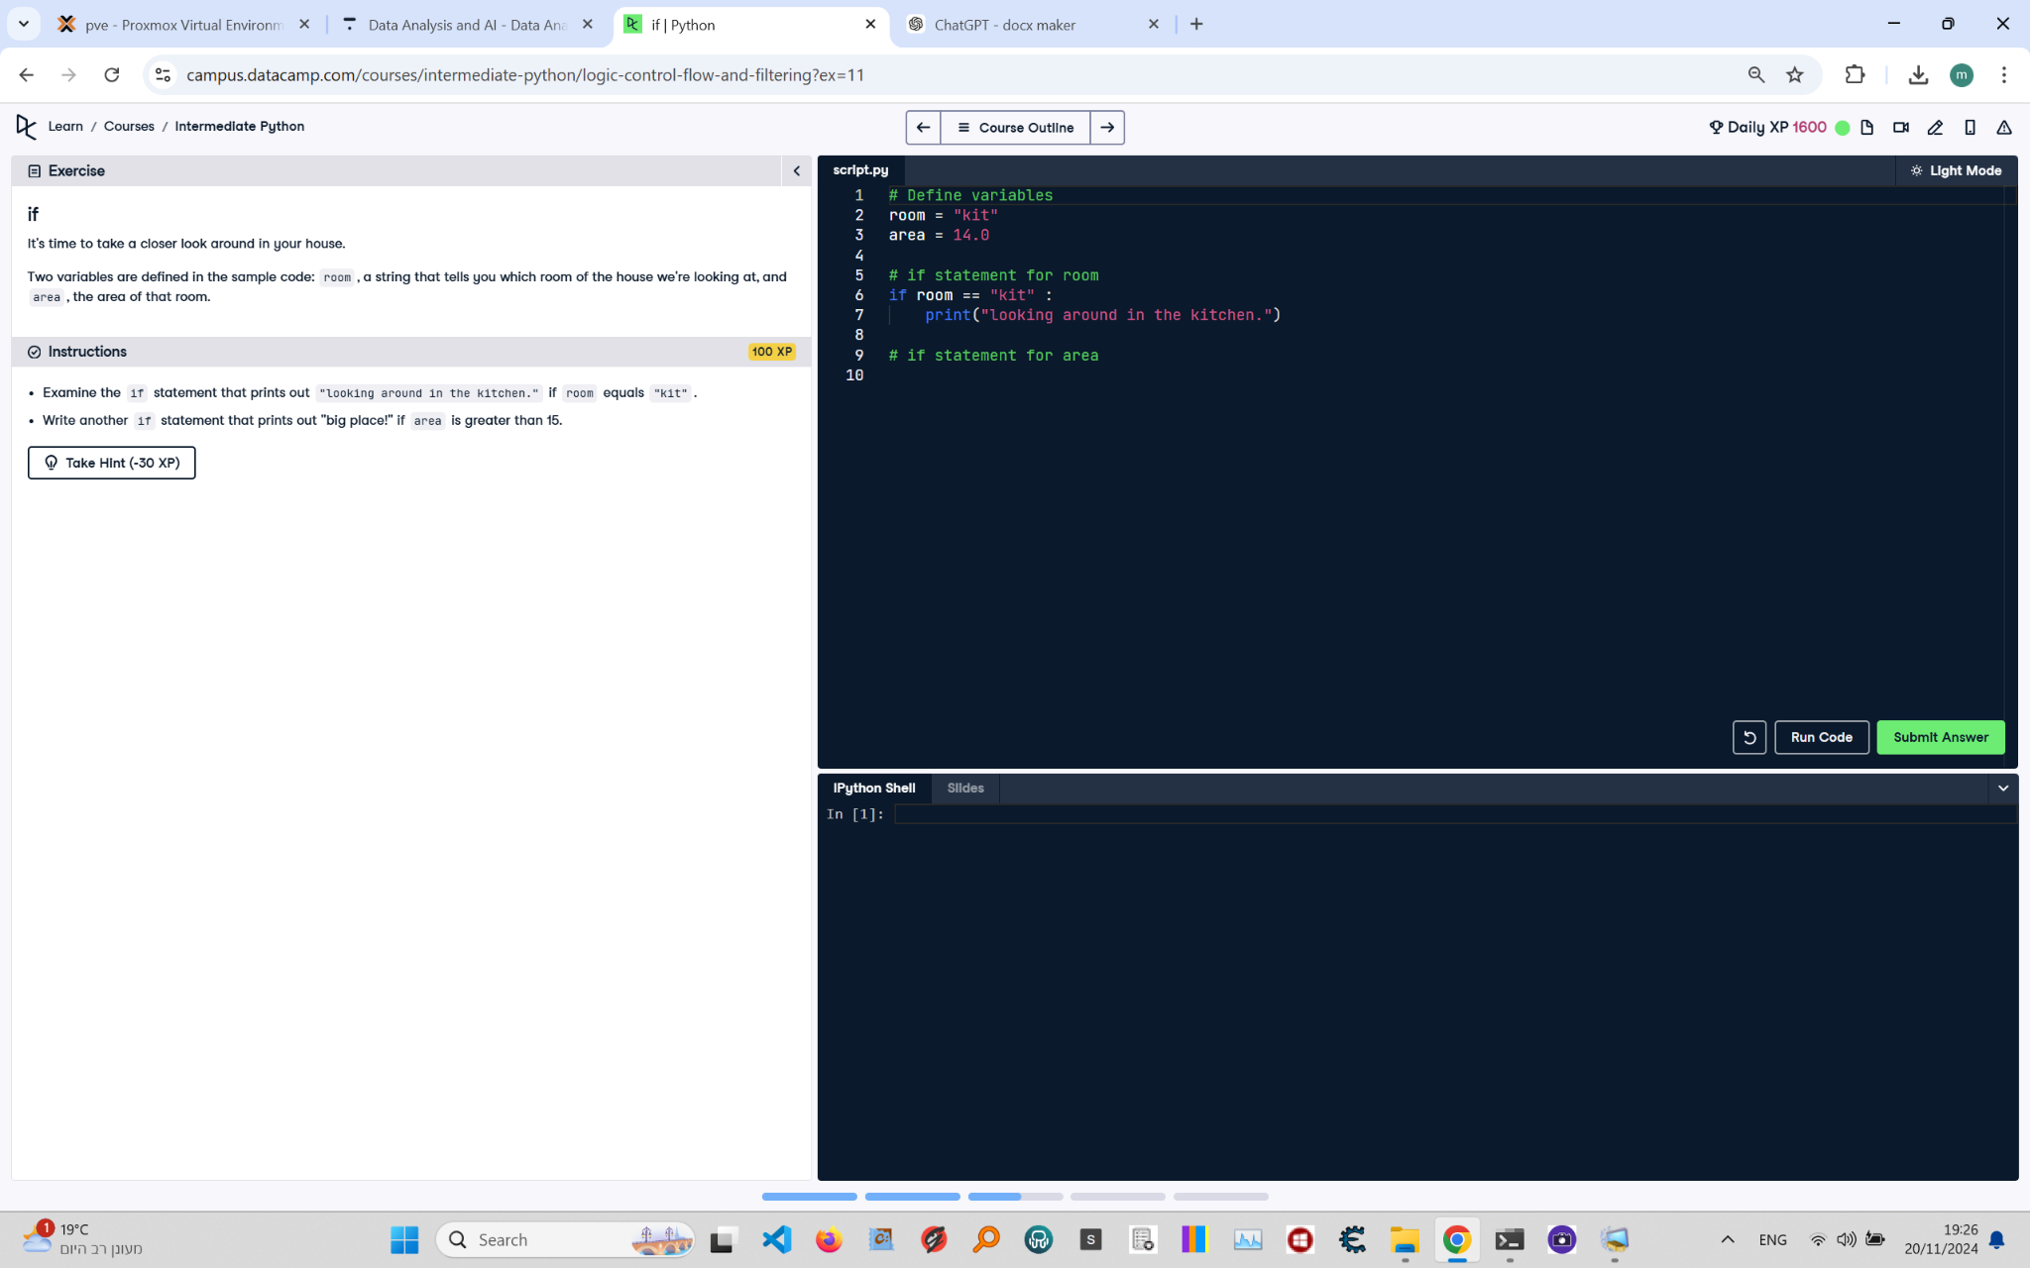

**Question:**

Two variables are defined in the sample code: `room`, a string that tells you which room of the house we're looking at, and `area`, the area of that room.  
1. Examine the `if` statement that prints out "Looking around in the kitchen." if `room` equals "kit".  
2. Write another `if` statement that prints out "big place!" if `area` is greater than 15.

**Answer:**

Here is the Python code that solves the problem:

# Define variables  
room = "kit"  
area = 14.0  
  
# if statement for room  
if room == "kit":  
 print("looking around in the kitchen.")  
  
# if statement for area  
if area > 15:  
 print("big place!")

**Explanation:**

1. **Variable Initialization**: The `room` variable is set to the string "kit" and the `area` variable is set to 14.0.  
2. **First if statement**: The `if` condition checks whether the value of `room` equals "kit". If true, it prints "looking around in the kitchen.".  
3. **Second if statement**: The `if` condition checks whether the value of `area` is greater than 15. Since 14.0 is not greater than 15, this block does not execute. If the value of `area` was greater than 15, it would print "big place!".